**Multiple Implementation BADI**

1. Go to tcode SE18.Give a BADI name starting with Z/X. Go to Utilities->Create Classic BADI.

(Do not click create)

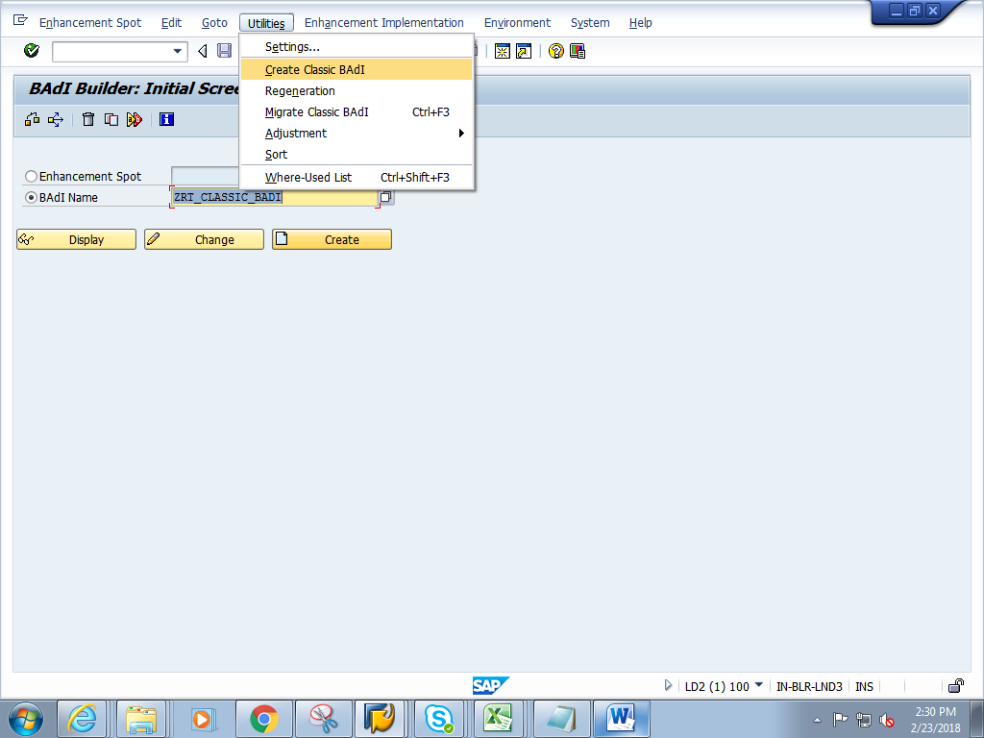

1. Give a short description. **Check on the Multiple Use and Filter Depend**Give Filter type as data element name **S_CARR_ID.**

Click on Interface tab

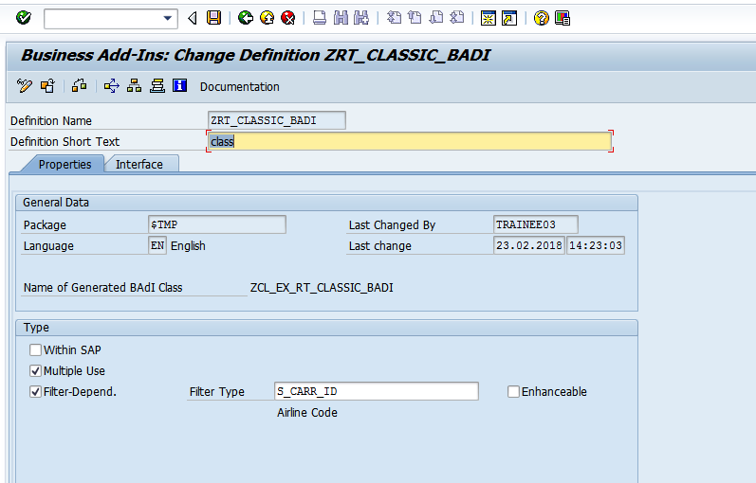

1. Double click on the interface.

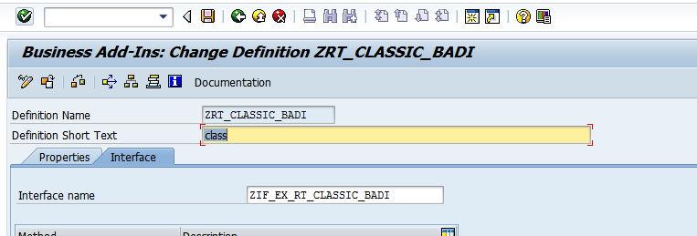

1. In the interface, add the method meth_Sflight as shown below. And add two parameters

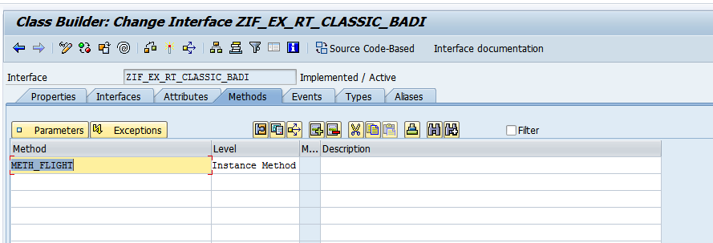

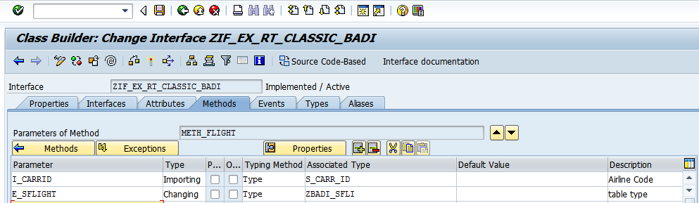

1. Save and activate the BADI definition
2. Go to se19 - Give BADI definition name. Click on create.

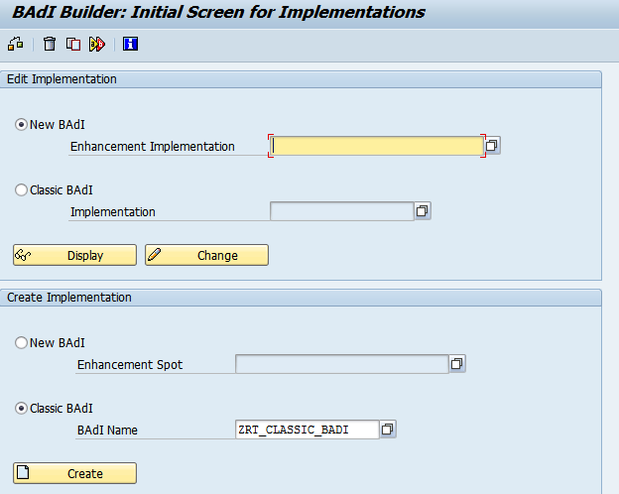

1. Create implementation 1 for the BADI

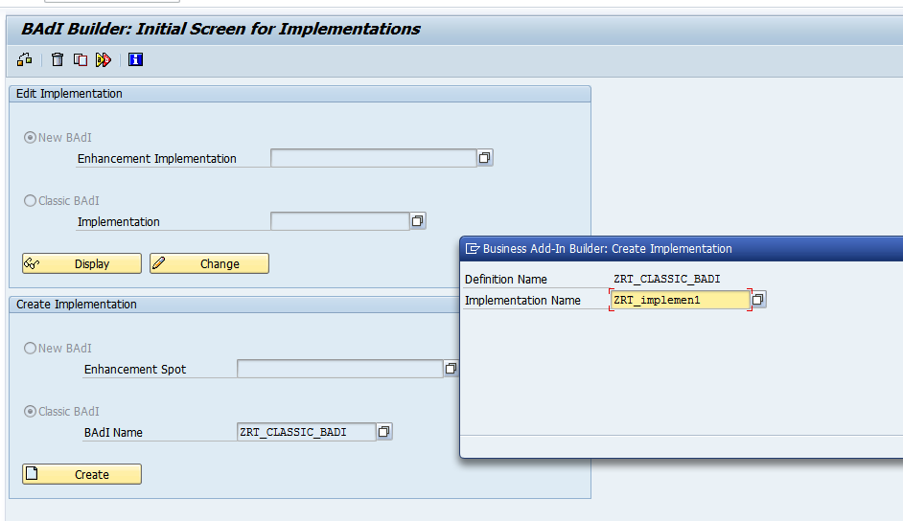

1. Give short description. **Give Filter value as AA.** Click on interface tab.

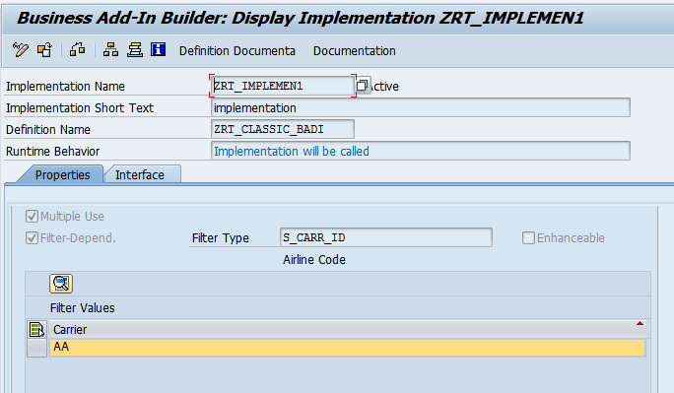

1. In the method , add the below code.

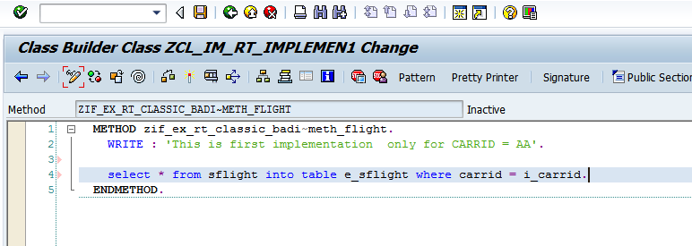

1. Save and activate the method , implementation. Go back.
2. Create implementation 2 from se19 ( Refer to steps from step 7 to step 9).

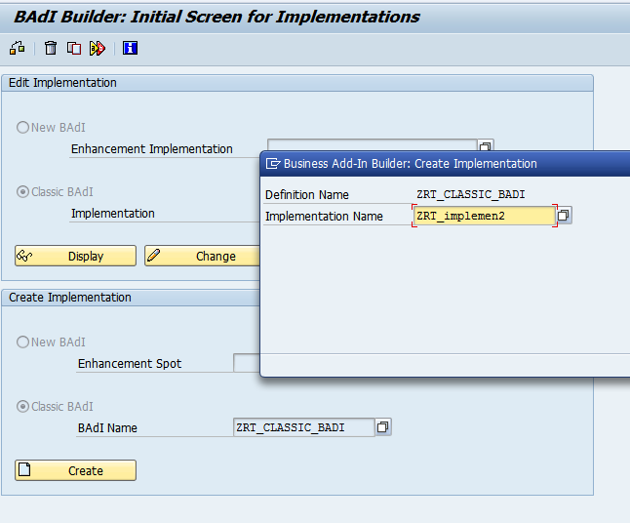

1. In the method of the second implementation , add the below code

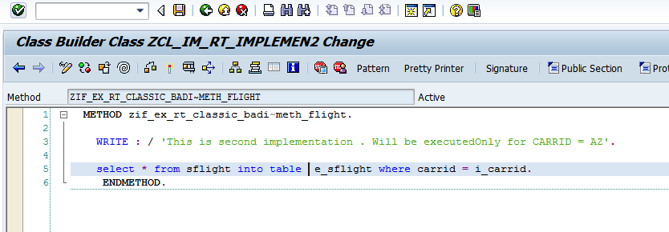

1. Save and activate the method and the second implementation
2. SE38 - Create a report and add the below code

*&---------------------------------------------------------------------*  
*& Report ZCLASSIC_BADI_PRG  
*&---------------------------------------------------------------------*  
*&  
*&---------------------------------------------------------------------*  
REPORT zrt_classic_badi_prg.  
  
INCLUDE zrtassic_badi_prg_top.  
  
  
PARAMETERS p_carrid TYPE s_carr_id.  
  
  
START-OF-SELECTION.  
  
  DATA obj1 TYPE REF TO  ZIF_EX_RT_CLASSIC_BADI."Interface from se19  
  
  
  CALL METHOD cl_exithandler=>get_instance  
    EXPORTING  
      exit_name = 'ZRT_CLASSIC_BADI' "Name of badi definition name  
*     null_instance_accepted        = SEEX_FALSE  
*  IMPORTING  
*     act_imp_existing              =  
    CHANGING  
      instance  = obj1  
*  EXCEPTIONS  
*     no_reference                  = 1  
*     no_interface_reference        = 2  
*     no_exit_interface             = 3  
*     class_not_implement_interface = 4  
*     single_exit_multiply_active   = 5  
*     cast_error                    = 6  
*     exit_not_existing             = 7  
*     data_incons_in_exit_managem   = 8  
*     others    = 9  
    .  
  IF sy-subrc <> 0.  
* Implement suitable error handling here  
  ENDIF.  
  
  
  
  CALL METHOD obj1->meth_flight  
    EXPORTING  
      i_carrid  = p_carrid  
      flt_val   = p_carrid  
    CHANGING  
      e_sflight = it_tab.  
  
  
  LOOP AT it_tab INTO wa_tab.  
    WRITE : / wa_tab-carrid,  
              wa_tab-connid.  
  ENDLOOP.

1. When CARRID = AA. Output is as follows

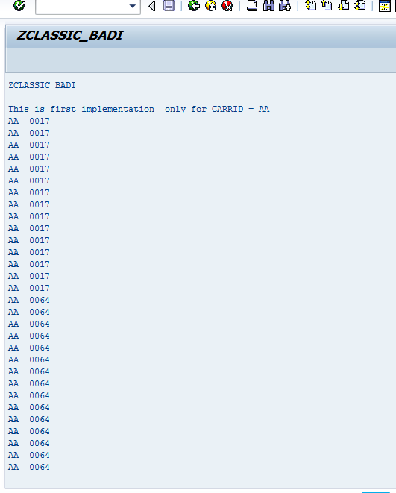

1. When CARRID = AZ

